**Maize Analytics**

How to reset your Maize Analytics password.

If you are unable to login to Maize at <https://ebas.maizeanalytics.com/account/login/>, you can reset your password at: <https://ebas.maizeanalytics.com/account/password/reset/>. An email will arrive in 1-3 minutes with reset instructions. Check your spam folder as some organization's systems may incorrectly block the email.

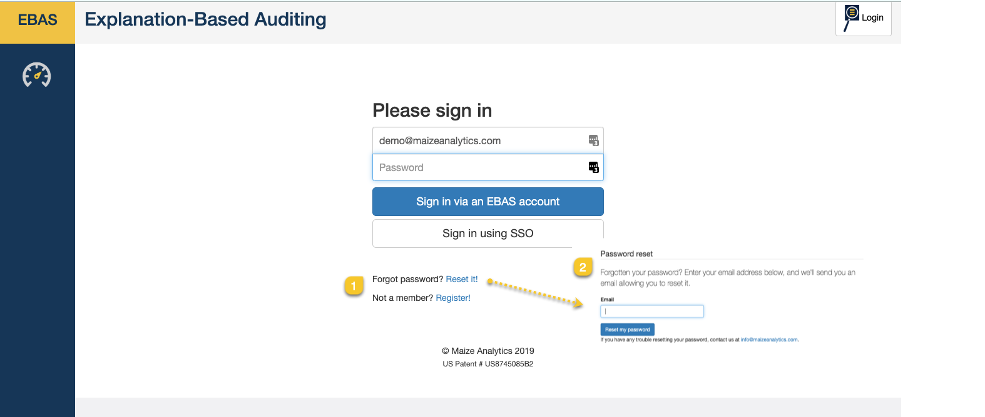

<https://support.maizeanalytics.com/portal/en/kb/articles/how-to-reset-your-maize-analytics-password>